Kol Simcha Torah Gazette
For parshas vayishlach 5785
Volume 9 Issue 12 (Whole #426) 13 Kislev 5785/ December 14, 2024
Printed L’illuy nishmas Nechama bas R’ Noach, a”h

For a free subscription, please forward your request to keren18@juno.com
Past emails can be found on the website ShabbosStories.com under Brooklyn Torah Gazette

BDE: Rabbi Meir Fendel, Zt”l, Founder of HANC
By Rabbi Yair Hoffman

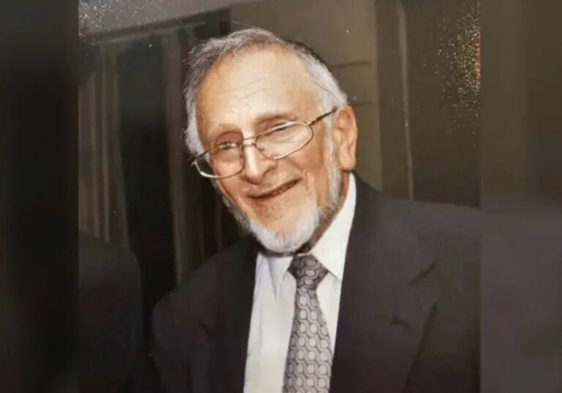

There are tens of thousands of former talmidim of Rabbi Meir Fendel who will be mounring this remarkable man who passed away over this weekend
It was 1953 and Long Island, New York had no Jewish school. It had a burgeoning Jewish community, but no Torah education whatsoever.
It was something that a young Rabbi Meir Fendel wished to rectify.
And with a handful of families and just 30 children, Rabbi Fendel founded HANC – the Hebrew Academy of Nassau County.
An old, three-story house in West Hempstead, known as the “Oppenheim Collins Estate,” was the chosen location to launch this ambitious educational venture. Despite the lack of funding for renovations, this 75-year-old property was transformed with unwavering determination. The living and bedrooms were converted into vibrant classrooms, and Rabbi Fendel selflessly stepped up as the Principal, forgoing any remuneration.
Into this historic setting, the first teacher, Anne Abelow, arrived, bringing her passion for educating young minds. She taught 1st grade in both Hebrew and English, her commitment shining through every lesson. Alongside her, an untiring secretary named Ruth Provda managed the endless paperwork, acting as nurse, den mother, and confidant to the eager children.
And so, in 1952, the Hebrew Academy of Nassau County (HANC) was born, taking root in this old “haunted house,” as it was once called. For four years, the fledgling institution made do with the limited space, until a new wing was built in 1956 to expand the growing school. The names of the key contributors and those present at the groundbreaking ceremony are now inscribed on a large parchment, a testament to the pioneering spirit that gave rise to this educational haven.
Rabbi Fendel’s pivotal role in conceiving, founding, and shepherding the growth of HANC over many years has left an indelible mark. Through his dedication and that of the early pioneers, they were able to plant the seeds of a vibrant Jewish educational institution that continues to thrive and transform young lives to this day.
His warm and loving smile opened up hearts and slowly but surely he built the school. He met with parents individually and they could not say no because he was so very genuine. Today, many of New York’s orthodox doctors were educated at HANC. Indeed, Nassau County’s Department of Health is run by a HANC graduate as well.
Rabbi Fendel had studied under Rav Chaim Pinchas Scheinberg zt”l in Yeshiva Chofetz Chaim in the 1940’s. Afterward, he became involved with Torah uMesorah and was one of those remarkable individuals that lived and breathed Chinuch.
In 1971, Rabbi Fendel conceived the “New Opportunities Program” which is still in existence 53 years later which allowed students with little or no Judaic background to attend a Jewish Day School while receiving an excellent General Studies education.
Rav Gottesman a”h who took over for Rabbi Fendel at HANC ,described Rabbi Fendel as the type of person who would spare no effort in ensuring that every Jewish child would receive a Torah education. Tuition was never a stumbling block to enable a child to enter HANC’s doorways under his leadership.
When he ultimately moved to Eretz Yisroel he brought a number of people with him on Aliyah. There are numerous people in Lakewood, who were his talmidim.
Rabbi Meir Fendel, although a follower of the Mizrachi movement kept a strong shaichus with Rav Scheinberg zt”l. He lived in Har Nof, Yerushalayim.
The funeral will be held tomorrow (Sunday, December 8th) at 12:30 at the Eretz Hachaim cemetery in Beit Shemesh.
Eretz Yisroel was always on his lips and mind. He once wrote: “The Torah is replete with references to Eretz Israel, so much so, that the great sage Rav Meir Simcha HaCohen, author of the Meshekh Chokhma writes: There is no Sedra in the Torah wherein there is no mention of Eretz Israel.” .
He further wrote that, “only in the land of Israel can one achieve the lofty purity of thought and action (avira de Eretz Yisrael makhkim). To the believing Jew, this extraordinary emphasis on Eretz Israel should be a paramount reason for wanting to attach himself to the land. The Meshekh Chokhma concludes with this amazing statement: From the time that Jerusalem and Zion were chosen, David in his psalms, Isaiah in his visions, Jeremiah in his admonishments, and Yechezkel in his parables did not cease to extol the mitzvah of living and settling the land.”
Rabbi Meir, of blessed memory, is also the father of journalist and author Hillel Fendel, a resident of Beit El, a writer for many years for Arutz Sheva – Israel National News. His other son, Rabbi David Fendel, is head of the Sderot yeshiva.
Rabbi Meir’s father, Rabbi Zalman Hillel Fendel was from Lithuania and married a Dershowitz. Reb Zalman Hillel worked very hard all day, when he arrived home the first thing he did was open up a Gemorah and learned for several hours. He was so exhausted that his family had to lift him up to get him to bed. This left an incredible impression on the family and both he and his brother Reb Zechariah zatzal, went into Chinuch and Kiruv and writing Seforim.
Arutz Sheva reports that after Rabbi Meir’s immigration to Israel, he taught at the Ora Institute and the Moriah Seminary for foreign students. Additionally, he established a summer camp for Diaspora girls, changing their lives and their attitude towards Israel and Torah. In summer, you can achieve what you learn in a whole year – an educational innovation he brought here to Israel.”
Rabbi Meir Fendel zt”l was a true hero in Klal Yisroel that created thousands of frum homes – facts on the ground. He changed the face of New York’s Jewish community.

Reprinted from the December 8, 2024 website of Yeshiva World.

Rav Avigdor Miller on
How Should We React to the News that the Pope Made a Jewish Nun a Saint?

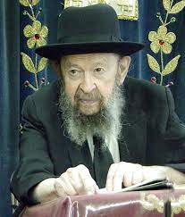

What the Pope does is none of our business. Only it’s a great pity on a Jewish soul that went lost. That’s all. The saint is now in Gehenom and she is getting the treatment that all the poshei Yisroel (Jewish sinners) get. Because we say, “You want to be a saint? So why weren’t you a frum Jewish woman? You have to forsake your people?”
And therefore, the whole subject is alien to our minds. It’s one more soul that went lost. So just because she’s a Catholic saint, what of it? And suppose she was a drug addict lying in a cellar, drugged with narcotics, is she any better off? And therefore, it’s a pity on all of them.

Reprinted from the Parshas Vayeitzei email of Toras Avigdor, - Tape #641 – May 1987
Jacob and the Illusion
To the Final Redemption
From the Teachings of the Lubavitcher Rebbe
Rabbi Menachem Mendel Schneerson, Zt”l

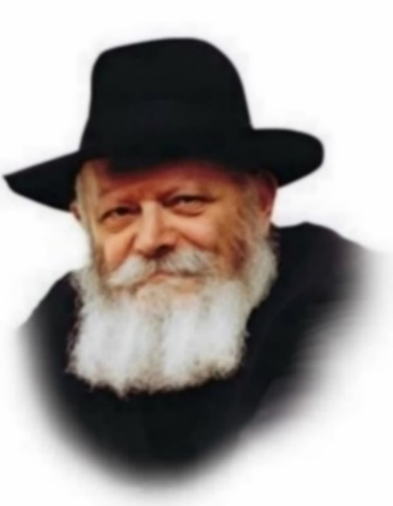

In this week's Torah portion, Vayishlach, Jacob recounts his years in Laban's household. Among other things he states, "I have ox(en) and donkey(s)." According to the Midrash, this is an allusion to the donkey of Moshiach, whom the Torah describes as "humble and riding upon a donkey."
A question is asked: Why did Jacob choose to allude to the Final Redemption in precisely this way?
The use of a donkey enables a person to travel more easily, conveying his belongings to a higher or more distant location. In the spiritual sense, it symbolizes the conquest and transcendence over materiality. ("Chamor," the Hebrew word for donkey, is related to "chomer," physical substance). Through refinement of the physical world, the soul is able to attain higher spiritual levels than it could otherwise achieve.
The donkey Moshiach will ride is the same animal that Moses made use of, as it states, "And he mounted them [his family] upon a donkey." It is also the same donkey that was used by Abraham when he went to the binding of Isaac, as it states, "And he saddled his donkey."
Abraham and his servants walked by foot, employing the donkey only to carry their belongings: the pieces of wood and the knife. Neither did Moses ride upon the donkey himself, but only mounted his wife and son on the animal's back. Moshiach, by contrast, will actually ride the donkey.
In the times of Abraham, before the Torah was given at Mt. Sinai, the physical world was not yet sanctified. When the Patriarchs performed mitzvot with physical objects, the physical objects remained unchanged. Materiality did not yet have the power to spiritually elevate. Abraham thus utilized the donkey only for carrying, as the holiness in the objects was limited to the actual time he used them for sanctified purposes.
In Moses' time, the ability to transform materiality into spirituality (through the performance of mitzvot) was granted. The lowest levels of human existence could thus be elevated. This partial conquest of the physical world is symbolized by Moses' mounting his wife and son upon the donkey.
It is only in the era of Moshiach that the superiority of the body over the soul will be fully revealed. At that time, even the highest levels of the soul will be elevated through the refinement of physicality. For this reason, Moshiach will actually ride upon the donkey.
Jacob's declaration thus alludes to his successful refinement of the physical plane of reality during his sojourn with Laban. Indeed, it indicated his readiness for the next step up - the elevation of the soul that follows such refinement.

Reprinted from the Parashat Vayishlach 5762/2001 edition of L’Chaim, a weekly publication of the Lubavitch Youth Organization in Brooklyn, NY. Adapted from Volume 1 of Likutei Sichot

******************************************************************
I Have Sojourned ("Garti")
with Laban (Gen. 32:5)

Comments Rashi, "The letters of 'garti' are the same as 'taryag' [613, the number of the Torah's commandments]. Jacob declared, 'With the wicked Laban I sojourned, but the 613 commandments I observed.'" With the word "garti" Jacob also implied that throughout his experiences with Laban he viewed himself as a ger (stranger), never even once considering himself "at home." Laban is symbolic of worldly affairs. When a Jew feels that he is only a "stranger" in this world, whereas his true "home" is in matters of Torah, the physical realm does contradict or oppose his spirituality. (Likutei Sichot)

Reprinted from the Parashat Vayishlach 5762/2001 edition of L’Chaim
Rabbi Berel Wein on
Parshat Vayishlach 5784

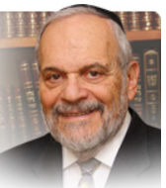

The struggle with Eisav’s angel, as described in the parsha, represents a spiritual and intellectual fight, a contest of ideas, beliefs and debate. The meeting with the physical Eisav in turn represents the struggle of the Jewish people to simply stay alive in a bigoted, cruel, and nearly fatal environment.

Yaakov does not escape unscathed from either confrontation. He is crippled physically and somewhat impoverished financially. Eisav’s “evil eye” gazes upon his children and Yaakov is relieved to escape alive, even if damaged in body and purse, separating himself from Eisav physically and from his civilization and worldview.

The scenario is pretty much set for the long dance of Jewish history, with the Jews always attempting to survive in a constantly challenging and brutal society governed by Eisav. The rabbis of Midrash discussed the possibilities of coexistence and even cooperation with Eisav.

Though this debate did not result in any permanent or convincing conclusion, the opinion of Rabbi Shimon ben Yochai that Eisav’s hatred of Yaakov is completely irrational and implacable seems to be borne out by history, past and present. The anti-Semitism in today’s seemingly enlightened world is so pervasive as to be frightening. And we seem to be powerless to do anything about it.

As is painfully obvious to all, these struggles for continued Jewish existence are ongoing and seemingly unending. All of the foreign ideas and current fads of Western society stand almost unanimously opposed to Torah values and traditional lifestyle. The angel of Eisav changes his program from time to time, but he is always opposed to Torah and moral behavior.

He wavers from totalitarian extreme conservatism to wild liberalism but always is able to wound the Jewish psyche and body no matter what philosophy or culture he now advocates. We limp today from this attack on Jewish values and Torah study and practice.

Jewish parents in America sue school boards for anti-Semitic attitudes, policies and behavior. Yet they would not dream of sending their children to a Jewish school or giving them an intensive Jewish education. The lawsuit is the indicator of the limp inflicted upon us by Eisav’s cultural angel.

All agree that Europe is currently a lost continent as far as Jews are concerned. The question most asked of travel agents by Jews today is “Can I wear a kippah on the street there?” Billions of dollars of Jewish treasure pillaged during World War II and immediately thereafter still lie in the hands of Eisav.

And yet we certainly would be satisfied if the world just let us alone but that seems to be a forlorn hope. So, our struggle continues but the L-rd’s promise to us that we will somehow prevail remains valid and true. And that is our hope for continuing on as loyal and steadfast Jews.

Reprinted from the current website of rabbiwein.com

******************************************************************

I am not worthy of all the mercies and
of all the truth You have done with
Your servant (Gen. 32:11)

The more benevolence G-d demonstrated to Jacob, the more it made him feel humbled and small. When G-d bestows His loving-kindness upon a person, it indicates a special closeness between the individual and G-d. Thus, the closer one's relationship with G-d, the more-humble and self-effacing he must be. (Tanya)
Reprinted from the Parashat Vayishlach 5762/2001 edition of L’Chaim.
Taking A Dispute With a
Jew to a Secular Court
By Daniel Keren

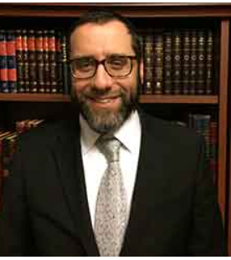
Rabbi Yehoshua Heber

One of the highlights of the recent Flatbush Veterans Day Hakhel Event was Rabbi Yehoshua Heber, rav of Khal Tomchei Torah (Torah Voda’as Minyan) and dayan of Bais Din Mishptai Yisroel who spoke on whether or not a religious Jew can go to a secular court in a dispute with another Jew.
Rabbi Heber pointed out that the question of Arkaos - Jews going to settle a dispute among themselves in a non-Jewish secular court is brought up in Parshas Mishpatim (Shemos/Exodus 21:1) where we learn that Jews should only go to a bais din, a Jewish religious court to resolve disputes with other Jews. This is true even if the secular court will give the same judgement as the Jewish bais din.
It is considered, Rabbi Heber said, that if a Jew goes to a secular court, it is as if he is honoring avoda zora, the worshiping of idols and this is a terrible dishonoring of the Torah of Moshe.
This is because Hashem chose us from all the nations of the world and gave us His holy Torah in order to live our lives and settle all of our disputes. One who goes to a secular court, Rabbi Heber said, is posul, disqualified according to the Mishna Breuer from davening from amud, bimah in a shul on the Yomim Noraim, the High Holidays.
Why is it that many Jews appear to be unaware of this serious prohibition against taking one’s legal complaints to a secular court? [And this would also include suing another Jew in a secular court in the Jewish State of Israel.] Besides the issur, prohibition of going to Arkaos (secular courts,) if one does so and is awarded by the secular judge or jury a settlement of money; this might constitute gezel, theft from his fellow Jew, including the money that he is forcing the losing defendant to have to spend for his attorney’s fees.
Even if one knows that he has been cheated by another Yid and that the bais din for various technical reasons will not give him the money that he is owed, he is still not allowed to go to the secular courts.
If a Jew has a complaint against a non-religious Jew who will absolutely not agree to go to the bais din, he is then permitted to take his case to the Arkaos, secular court. But he should first ask a Jewish religious court to issue a summons to the non-religious Jew and after the non-frum Jew ignores the summons, the other Jew is free to bring his complaint to a secular court.
Similarly, if another Jew summons a Jew to a secular court, is the defendant thereby allowed to go to the secular court in order to defend himself? Rabbi Heber said that the Jew being summoned by the other Jew to the secular court must first go to a bais din and request that they issue a hazman, summons against the Jew to rather settle the dispute in a religious court. If at that point after being issued an hazman and the plaintiff refuses to come to the bais din, the defendant is now free to defend himself in the Arkaos.
Even to threaten another Jew to take him to a secular court and that threat results in that other Jew agreeing to settle out of court is forbidden, Rabbi Heber said. And whatever money the first Jew gets as a result of that tactic is considered as “stolen” money.
Can a frum Jewish lawyer represent another Jew who wants to sue a third Jew in secular court? If the attorney can persuade him to take his case first to a beis din, the lawyer has to do so. If without your help, that Jew who wants to sue the other Yid won’t be able to pursue his claim in a secular court, the Jewish lawyer is forbidden to represent this client in the secular court. If, however, he can indeed find another lawyer to represent him without your services, the frum lawyer can then represent this Jewish client.
Rabbi Heber noted that if a Jew does bring his complaint against another Jew to a secular court and loses the case, he cannot then bring his complaint to a religious Jewish court.
The most common heter, permission to go to a secular court is if the person you are suing is a tough guy and he will not listen to the p’sak, decision of the bais din. This heter however, has to be signed by three dayanim (judges of the bais din). If one gets a heter from his rav alone, but who doesn’t want his signature revealed publicly, such a document is worthless.

Reprinted from the November 29, 2024 edition of The Jewish Connection.
Did Esau Really
Forgive Jacob?
By Mordechai Rubin

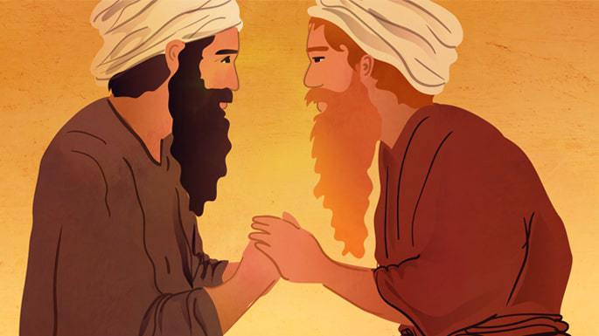
Art by Sefira Lightstone

After Jacob received the coveted blessings intended for Esau, he was compelled to flee to his mother’s family in Haran to escape Esau’s wrath. After spending 20 years in Haran, G-d appeared to Jacob and instructed him to return home, promising, “I will be with you.”¹ Notwithstanding G-d’s promise of protection, Jacob took a number of precautions to prepare for his encounter with Esau and his 400 men: he sent messengers and gifts to placate Esau, he prayed, and he actively prepared for war.
But when the brothers finally met, instead of attacking Jacob, Esau rushed forward, embraced him, and kissed him. Was this a sudden change of heart? Did Esau experience a moment of repentance? Below, we will explore how the biblical commentators interpret this episode.

1. Esau Was Placated by Jacob Prostrating Himself - Rashi
Rashi (Rabbi Shlomo Yitzchaki 1040 – 1105) understands that when Jacob prostrated himself before Esau, he evoked Esau’s mercy. This appears to be based on the Midrash which states that “He did not cease to bow down until the attribute of justice was turned to mercy.”² Rabbi David Kimhi (1160 – 1235), known by the acronym Radak, expands on this and explicitly states that at that moment, Esau forgave Jacob entirely.³ Gersonides (Levi ben Gershon, 1288 – 1344) commonly known as Ralbag, adds that when Esau saw that Jacob seemed remorseful, as evidenced by him prostrating himself, they embraced and kissed like the long-lost brothers they were.⁴

2. Esau Forgave Jacob Before They Even Met - Rashbam & Chizkuni
Rashi’s grandson, Rabbi Shmuel ben Meir (1085 – 1158), known as Rashbam, interprets these verses in a surprising manner. Although most commentaries understand the report that Jacob received that Esau was approaching accompanied by 400 men as a threat of war, Rashbam understands these 400 men as a guard of honor for Jacob. According to Rashbam, Esau harbored no ill feelings toward Jacob during this episode, even though that is evidently not how Jacob read the situation, as he clearly feared for his life after receiving the report. Still, according to this understanding, Esau’s intentions were good.
As proof, Rashbam cites similar verbiage in Exodus where the verse describes Moses’ return to Egypt. After being forced to flee Egypt —for having killed an Egyptian who was harming a Jew—Moses eventually settled in Midian where he married and raised his family.
While tending to the flocks of his father-in-law Yitro, G-d revealed Himself to Moses in the famous episode of the burning bush. During this exchange with G-d, in which Moses expressed his reluctance to serve as the Divine ambassador, G-d described Aaron’s reception of Moses upon his return. There, the verse uses the exact same language as in our verse in Genesis: “He is coming forth toward you, and when he sees you, he will rejoice in his heart.”⁵ This phrase unmistakably conveys a joyful and heartfelt reception.⁶
This view is echoed by Rabbi Hezekiah ben Manoach (1250 - 1310) known by the title of his commentary Chizkuni.⁷

3. It Was a Fleeting Moment of Compassion - Sifrei
When Jacob and Esau finally met, Esau embraced and kissed Jacob. In the Torah scroll, small dots appear over the Hebrew word for “and he kissed him” (וַֹיִֹשָֹׁקֵֹהֹוֹּ). In interpreting these dots, the Midrash Rashi cites reads as follows:
[Some interpret the dots to mean that] he did not kiss him wholeheartedly. Rabbi Simeon ben Yochai said: It is a well-known tradition that Esau hated Jacob, but his compassion was moved at that time and he kissed him wholeheartedly.⁸
This second explanation seems to imply that while the kiss may have been genuine, it was not a true reconciliation. At the end of the day, Esau’s hatred for Jacob endured.⁹

4. G-d Orchestrated a Change of Heart - Malbim
In a similar vein, Rabbi Meir Leibush (1809 – 1879), more commonly known as the Malbim, notes on the words, “And Esau ran toward him,” that, “G-d changed his hate to love.” This means that Esau himself did not forgive Jacob or even harbor any positive feelings for him. G-d, however, had promised Jacob that He would protect him. He therefore intervened to change Esau’s intentions.¹⁰

5. He Attempted to Bite Jacob - Midrash Rabbah
This approach, cited by various commentators, reconstrues Esau’s kiss as an attempt to bite Jacob’s neck. G-d performed a miracle and turned his neck into a solid block of marble. In this reading, the dots allude to the fact that this was not a typical kiss. Some note that Rashi does not cite this explanation as it does not align with the simple reading of the text.¹¹

6. The Angels Jacob Sent Affected a Change in Esau - The Rebbe
In the [Lubavitcher] Rebbe’s reading, the angels Jacob sent¹² were able to affect positive change in Esau. Esau’s ability to interact with these angels meant that even though he was not fully transformed, he was still able to reach a point of reconciliation. This interaction set the groundwork for the kiss that would take place when they met. This coming together of Jacob and Esau was an important breakthrough. It showed that even in this physical world of falsehood, Esau, who represents the “other side,” bows to Jacob—the side of holiness.¹³

7. Esau Had the Ability to Bring Ultimate
Redemption - Rabbi Shneur Zalman of Liadi
In this kabbalistic reading, Rabbi Shneur Zalman of Liadi explains that Jacob recognized Esau’s unique strengths and understood that achieving the world’s ultimate destiny required combining those qualities with his own. Jacob was sure that he had successfully redeemed the sparks of holiness necessary to herald in the Ultimate Redemption.
This profound spiritual achievement affected their reconciliation, culminating in the kiss that Esau bestowed upon Jacob. Ultimately, however, Esau was not ready. He was still very much entrenched in the physicality of this world—as represented by the 400 men that accompanied him.¹⁴.

Footnotes

1. Genesis 31:3
2. Midrash Rabbah ibid.
3. Radak Ibid.
4. Ralbag ibid.
5. Exodus 4:14.
6. Genesis 32:7.
7. Genesis 32:7.
8. Sifrei, Numbers 69:2.
9. For a lengthy analysis of this Midrash cited by Rashi, see Likkutei Sichot, vol 20, p 144.
10. Malbim Genesis 33:2.
11. Maskil le-David 33:4.
12. Rashi Genesis 22:4.
13. Torat Menachem 5742, vol 1, p 457.
14. See Sichot Kodesh 5737, Shabbat Parshat Vayishlach, section 6, and Torah Or, Parshat Vayishlach, p 24b.

Reprinted from the current website of Chabad.Org

Tefillos for Rabbi Paysach J. Krohn

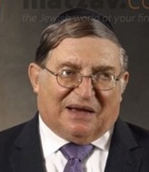

All are asked to daven for Rabbi Paysach J. Krohn, the renowned and beloved maggid, bestselling author and noted mohel, who was taken to the hospital as Shabbos began due to a stroke.
Rabbi Krohn was at the Agudah convention at the Armon Hotel and Conference in Stamford, Connecticut, when the incident occurred. Hatzolah immediately responded and transported him to a local Stamford hospital, where he is currently receiving treatment.
Rabbi Krohn had addressed a session at the Agudah Convention on Friday morning and was scheduled to speak again on Friday night.
All are asked to daven for a refuah sheleimah for Paysach Yosef ben Hinda.

